Caches :

Loops : Temporal Locality

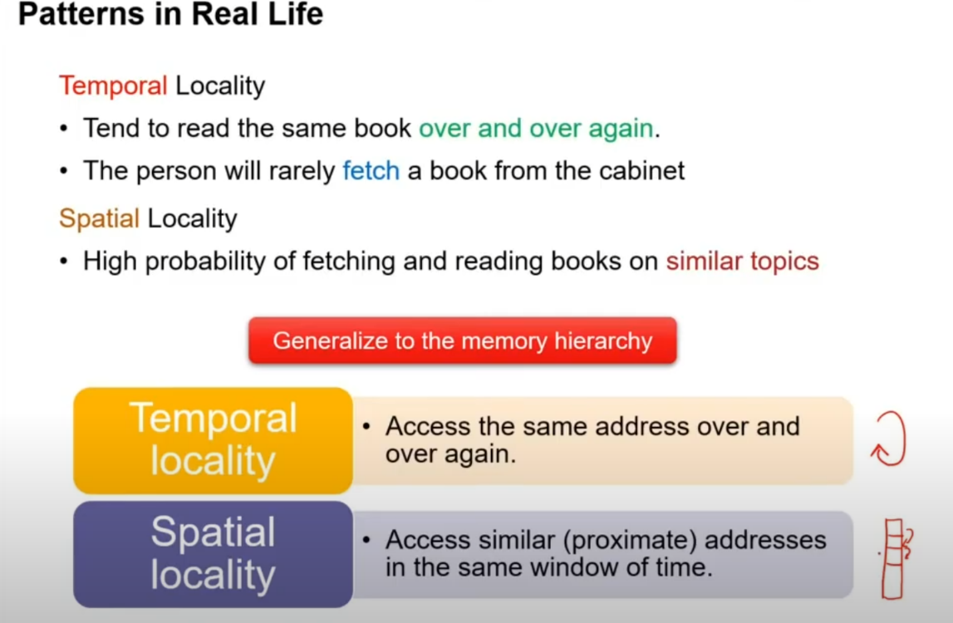

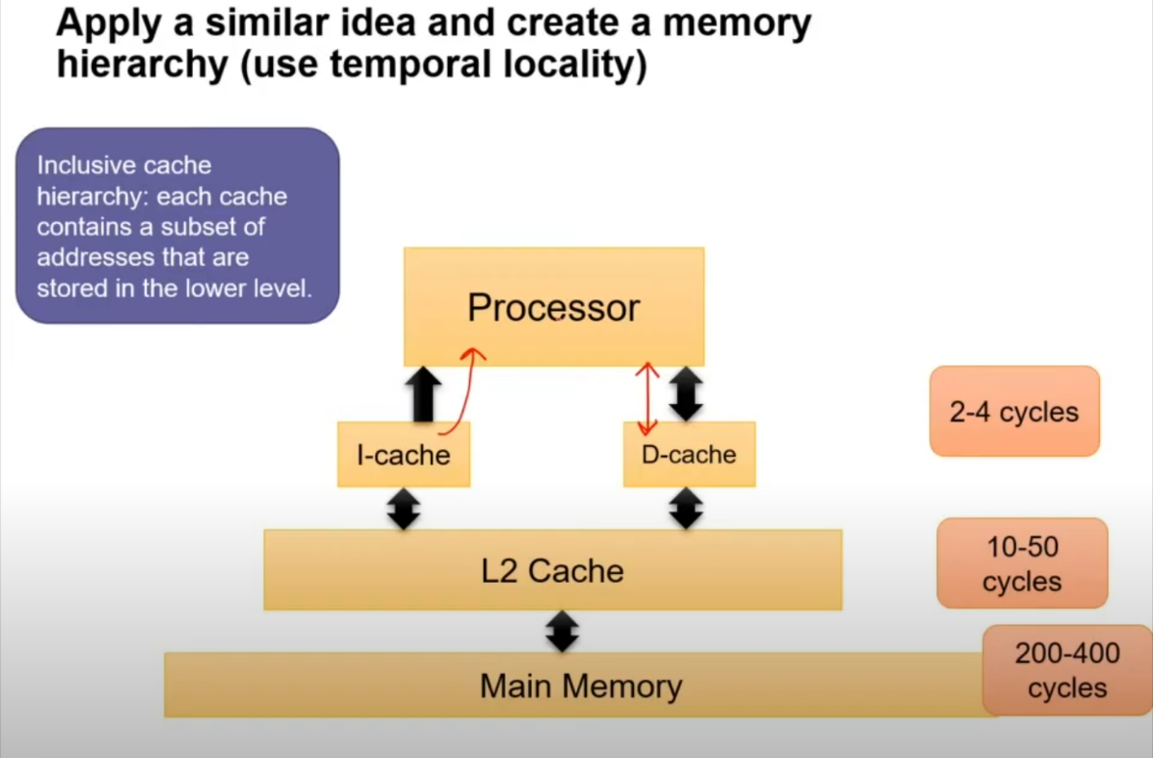

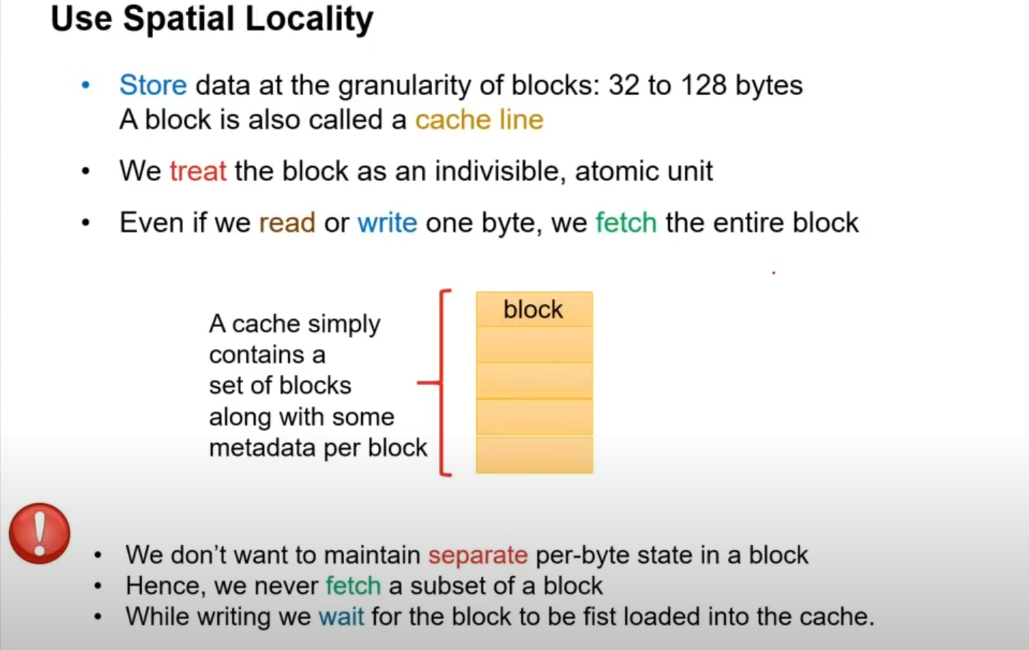

Even if we want to write just 4B of data to cache line we fetch whole block modify it and update the cache line. Like 4B updated and rest 60B are fetched from lower level (L2 or L3 or Main Memory). We don’t want to have partially formed block. Some written bytes and rest unknown bytes. Remembering the extra information that only few bytes are latest and rest are same some extra logic efforts are required. Hence, we never operate on subset of block.

Metadata : Additional information for the cache line/block

Types of Cache :

* Direct Mapped
* Fully Associativity
* Set Associativity

Direct Mapped : Destructive Aliasing.

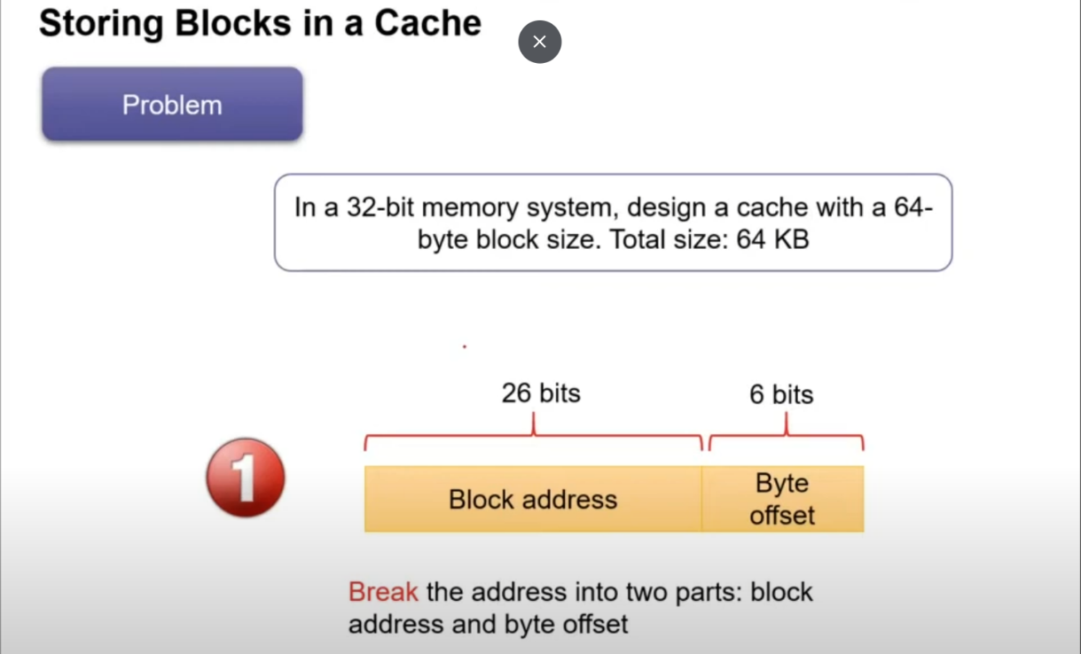

Cache Size (C) = No. of cache Lines (S) * Block Size(B).

Block Size = Size of 1 Cache line = 64B. ----------- 6-bit block offset

S = 64KB/64B = 1024 lines. ------------------------- 10-bit Index for Indexing the Cache line.

Tag Size = 32 – 10 – 6 = 16 bit.

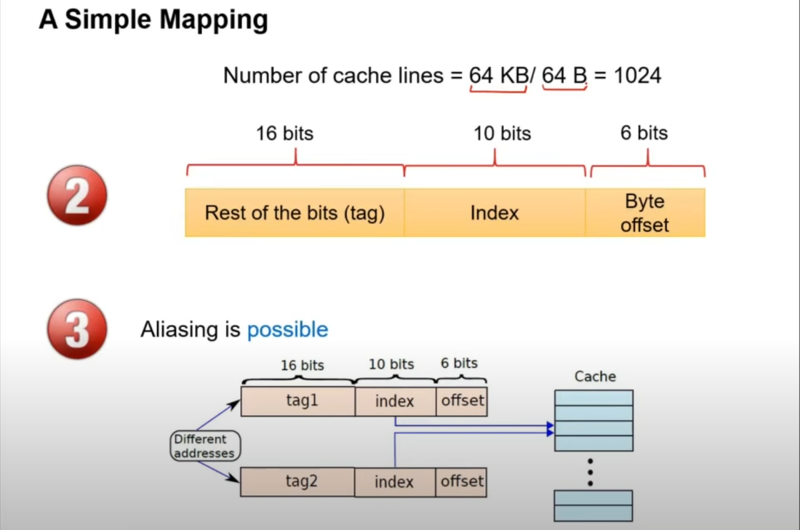

Tag is metadata. So, the cache line is concatenation of {TAG,BLOCK_DATA}.

Just like improved from 0% to 50%. Now their probability of success got increased.

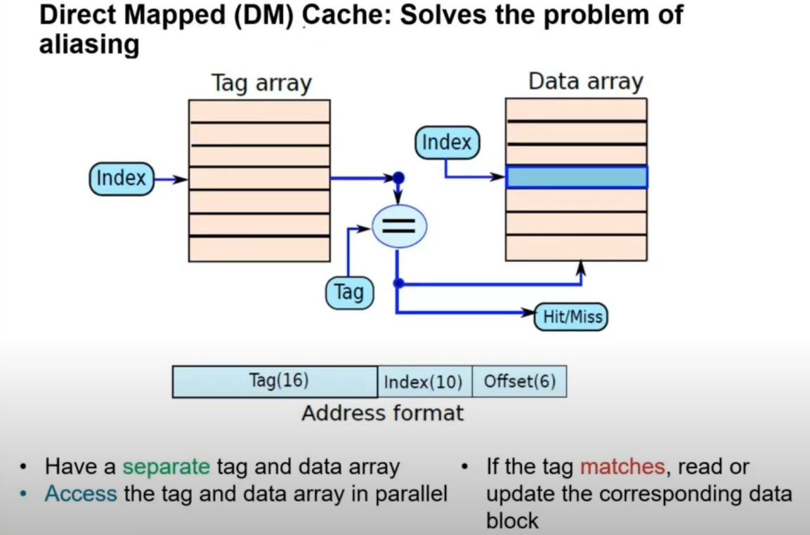

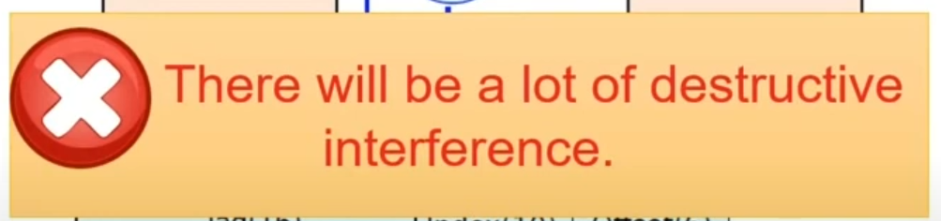

Fully Associative Cache : No Index bit. TAG | Block Offset.

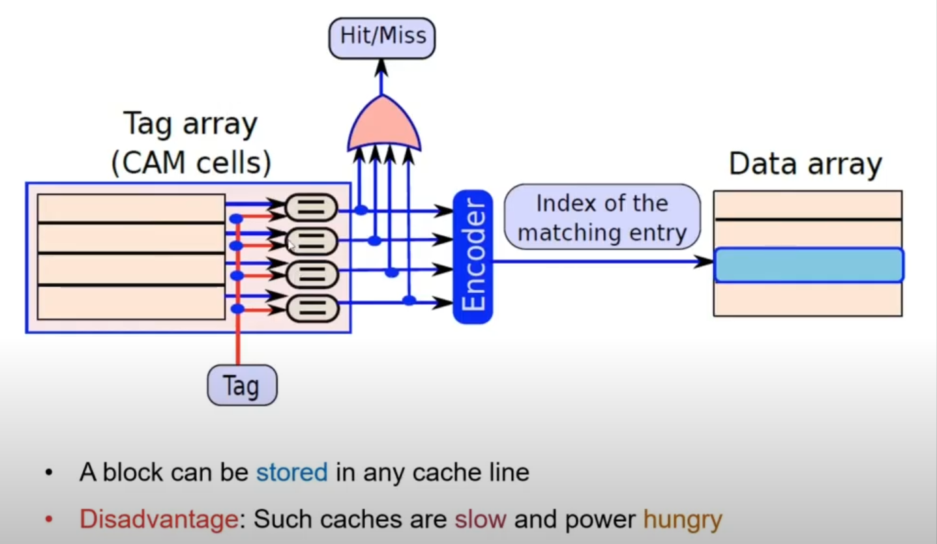

C = S * B. There is no index. Direct the Tag itself is used for Indexing.

Set Associative cache :

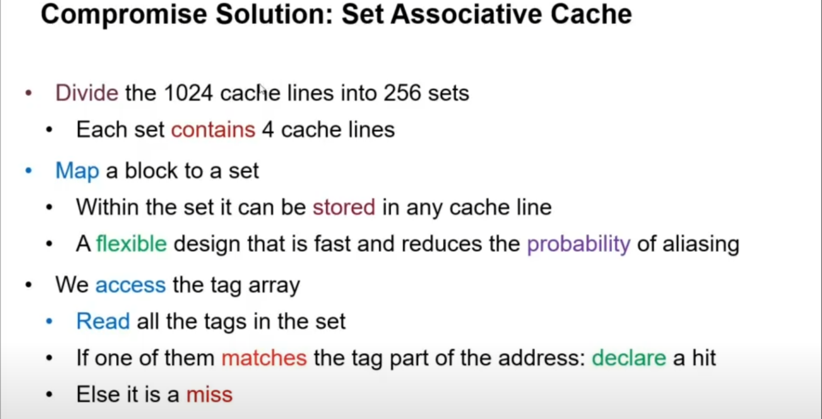

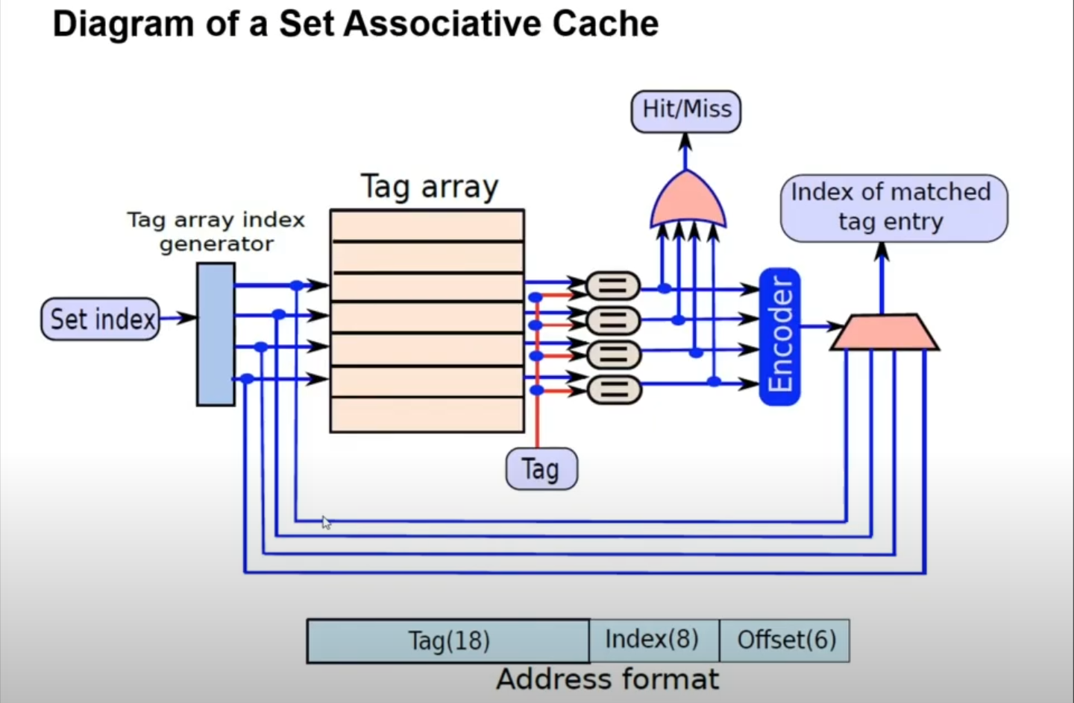

Read Operation :

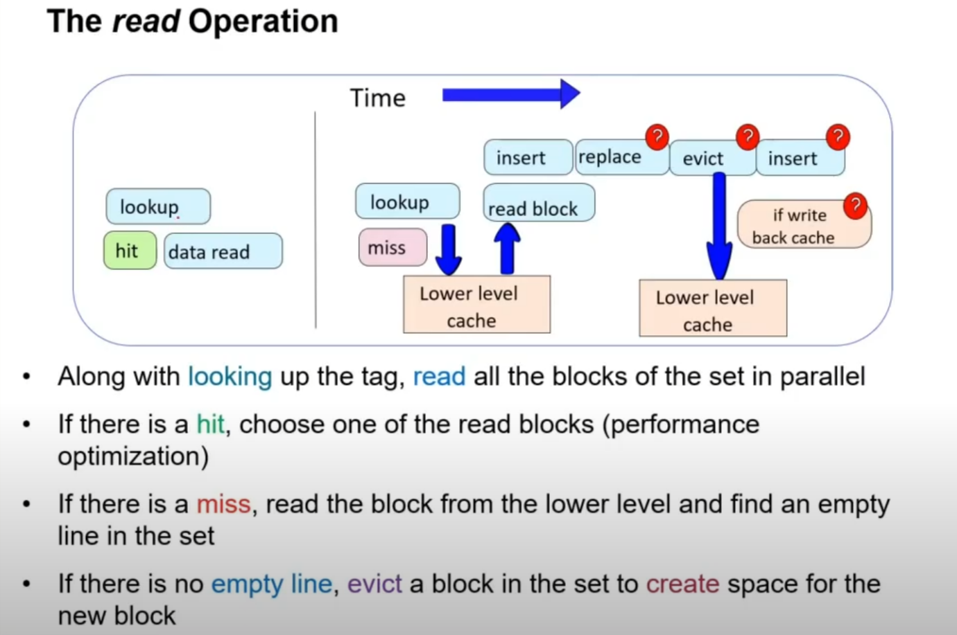

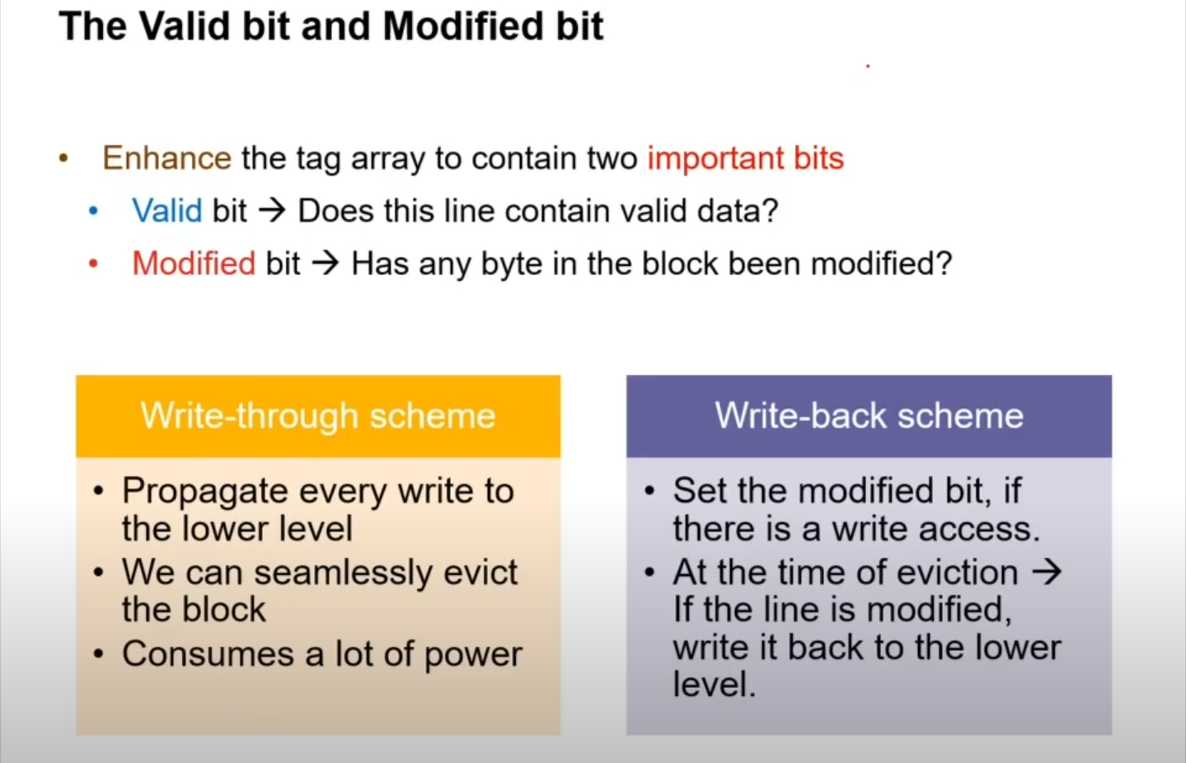

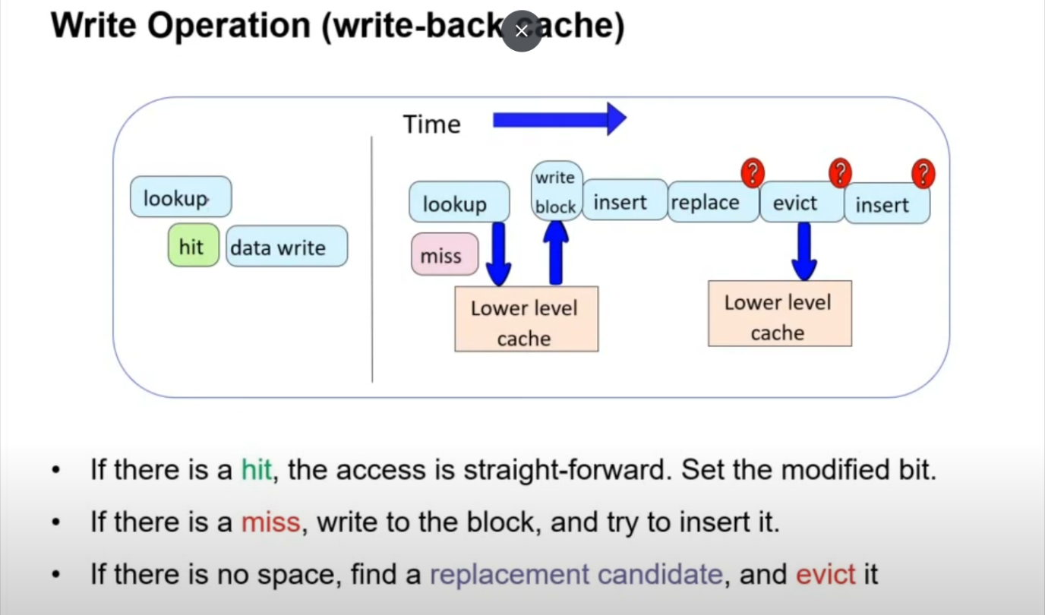

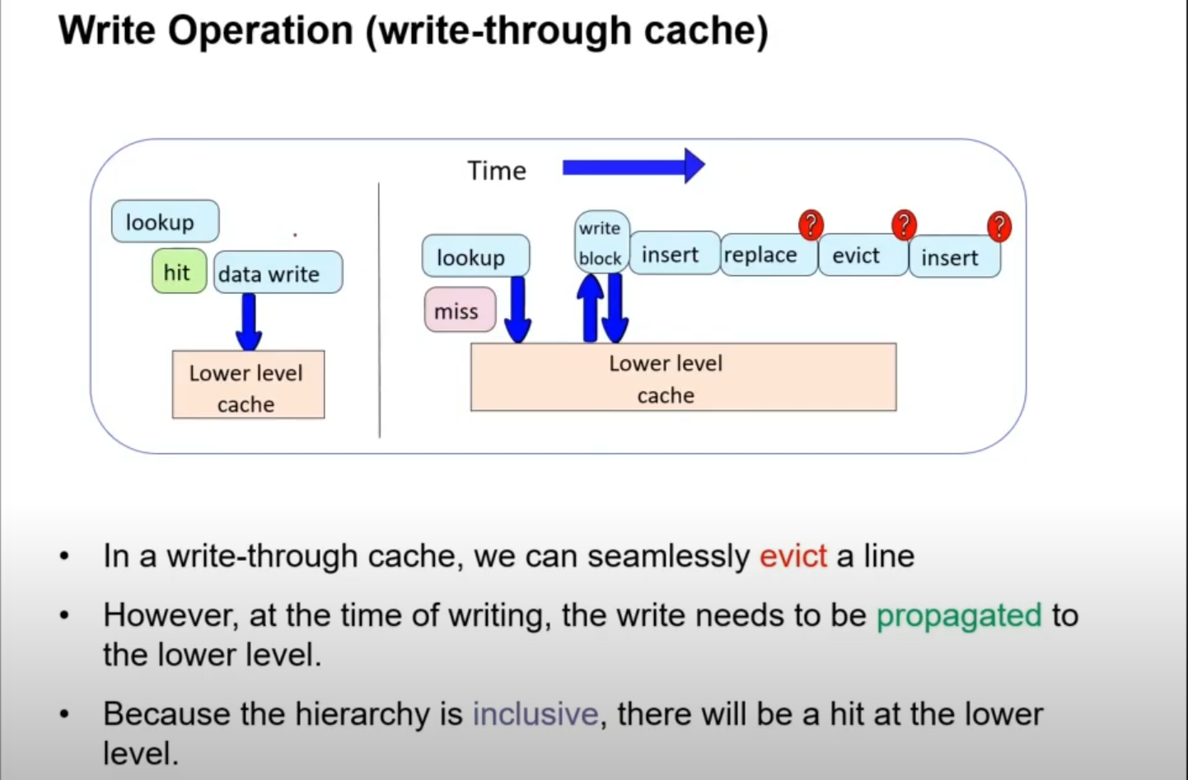

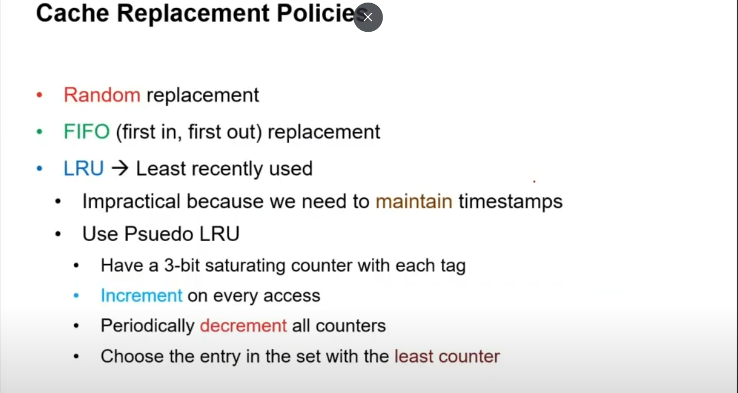

ARM implements pseudo LRU as its Cache Replacement policy.

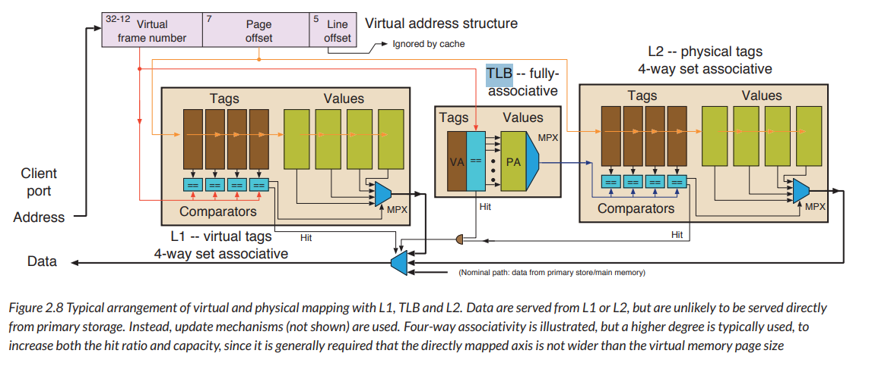Cache Usage Example :

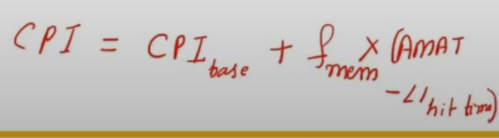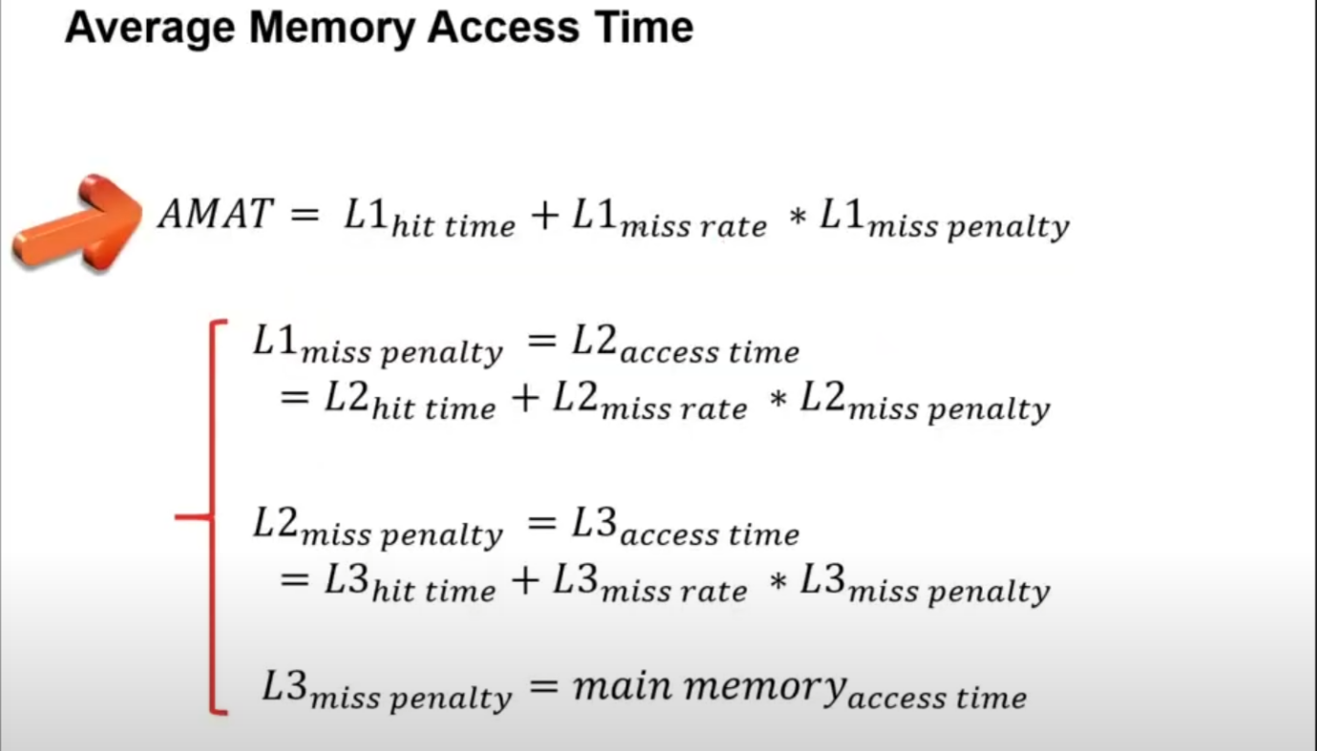AMAT :

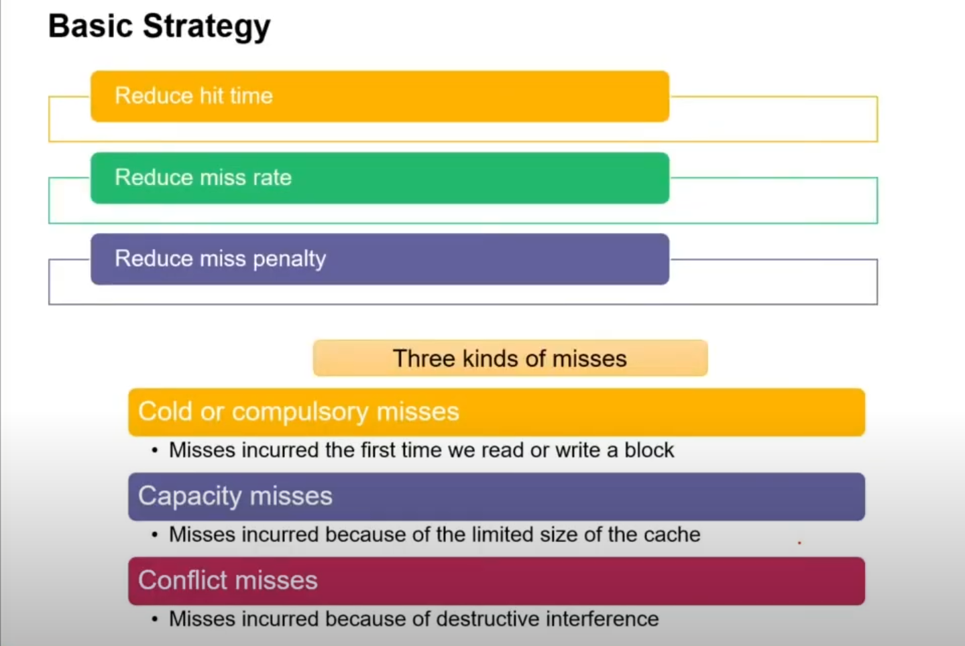

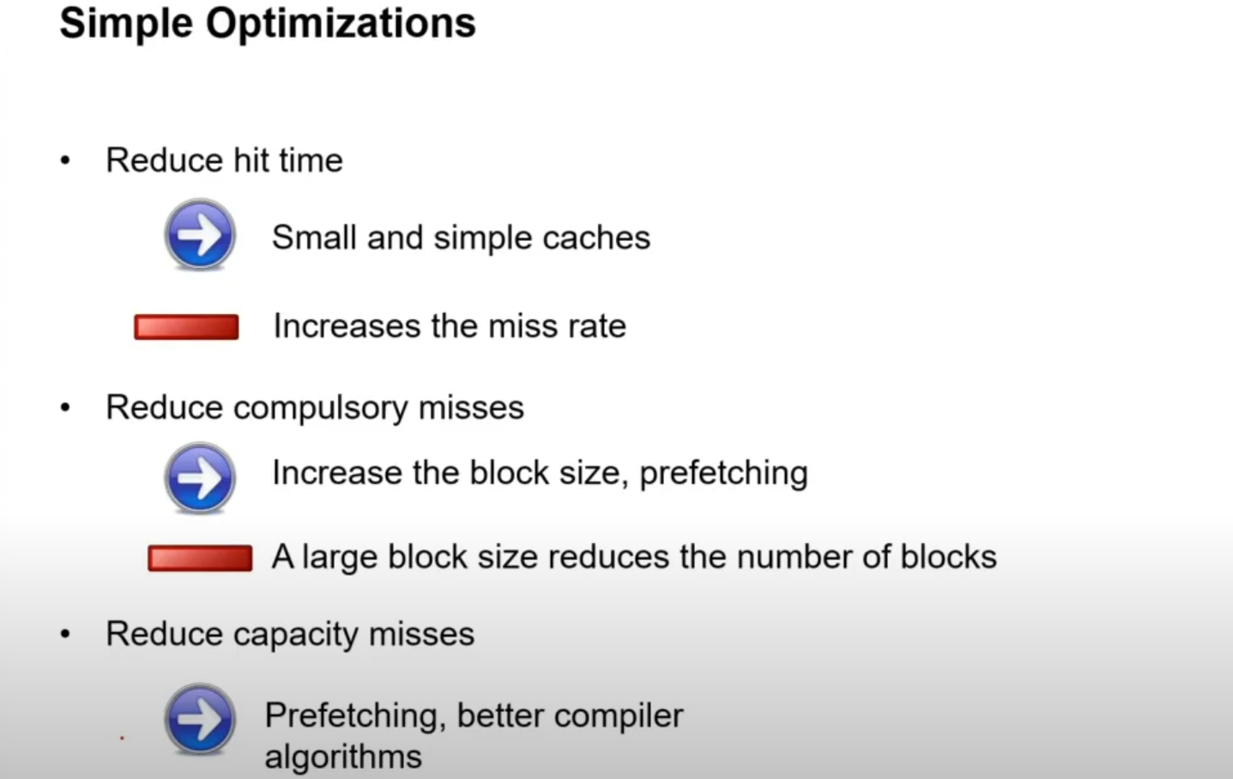

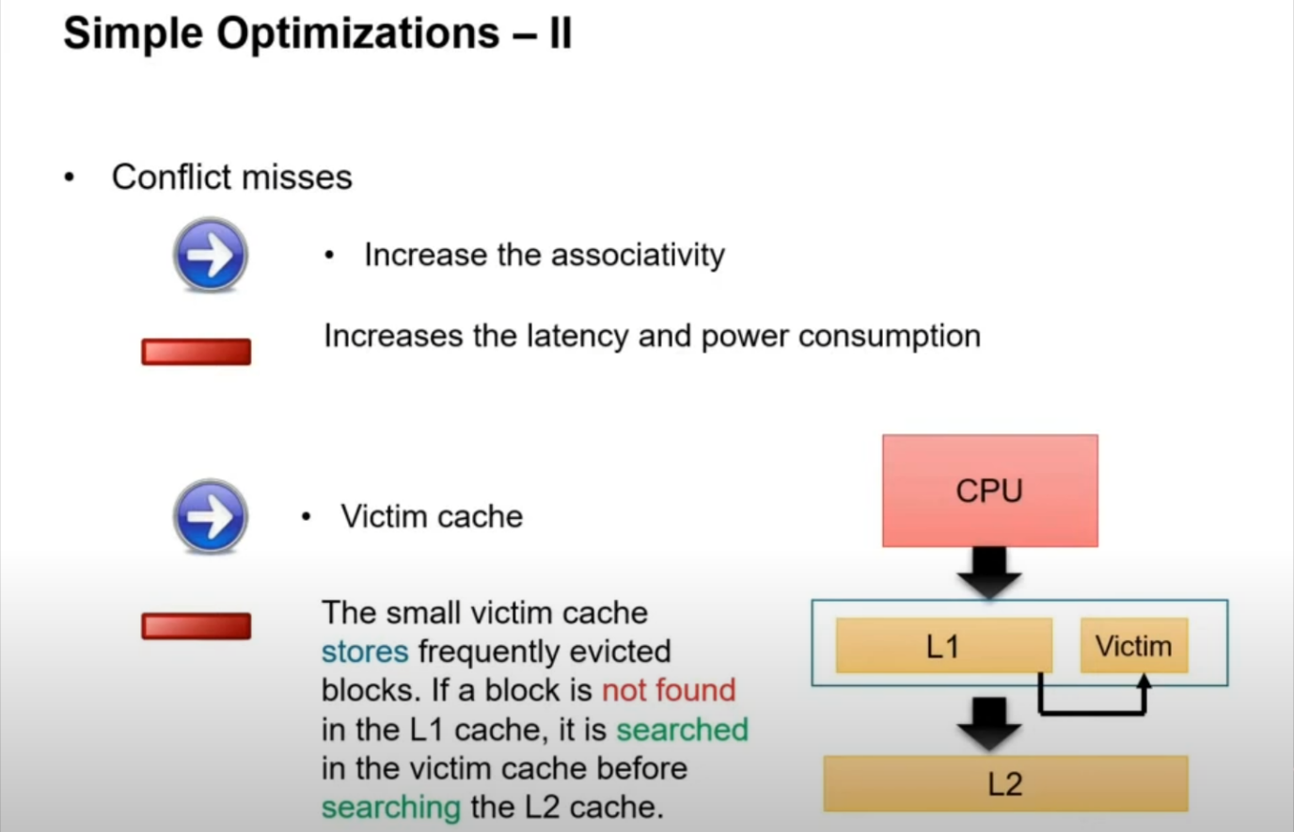

Write buffer and Victim cache : FA cache.

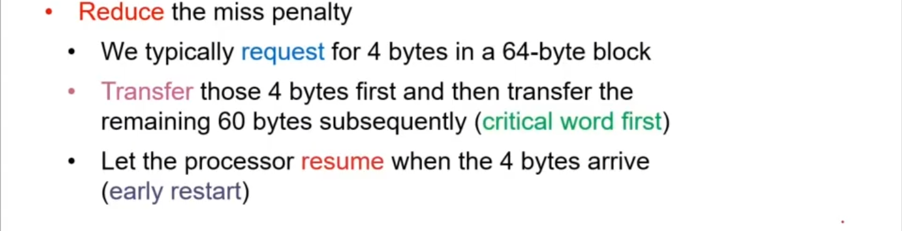

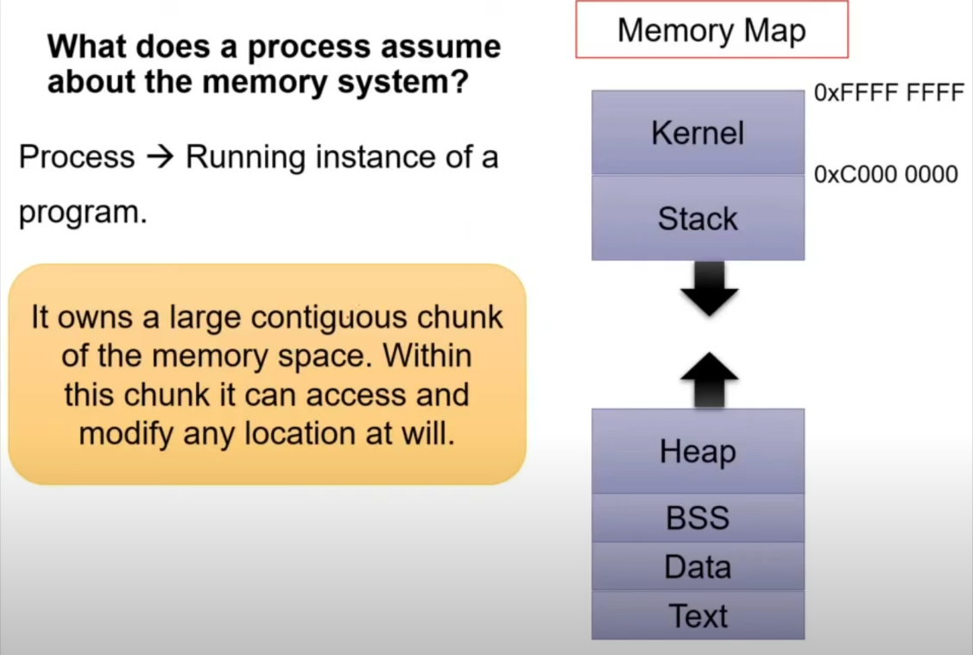Virtual Memory :

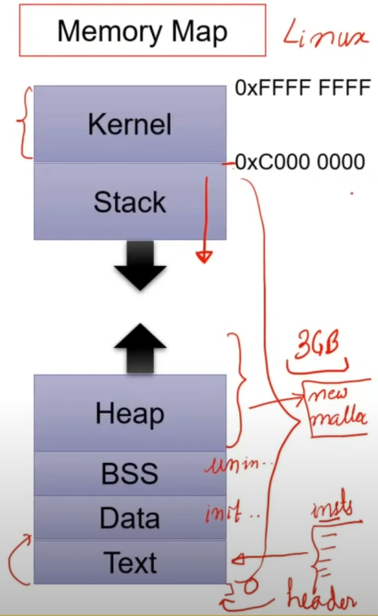

Virtual Memory solves the Overwrite and Size Problem.

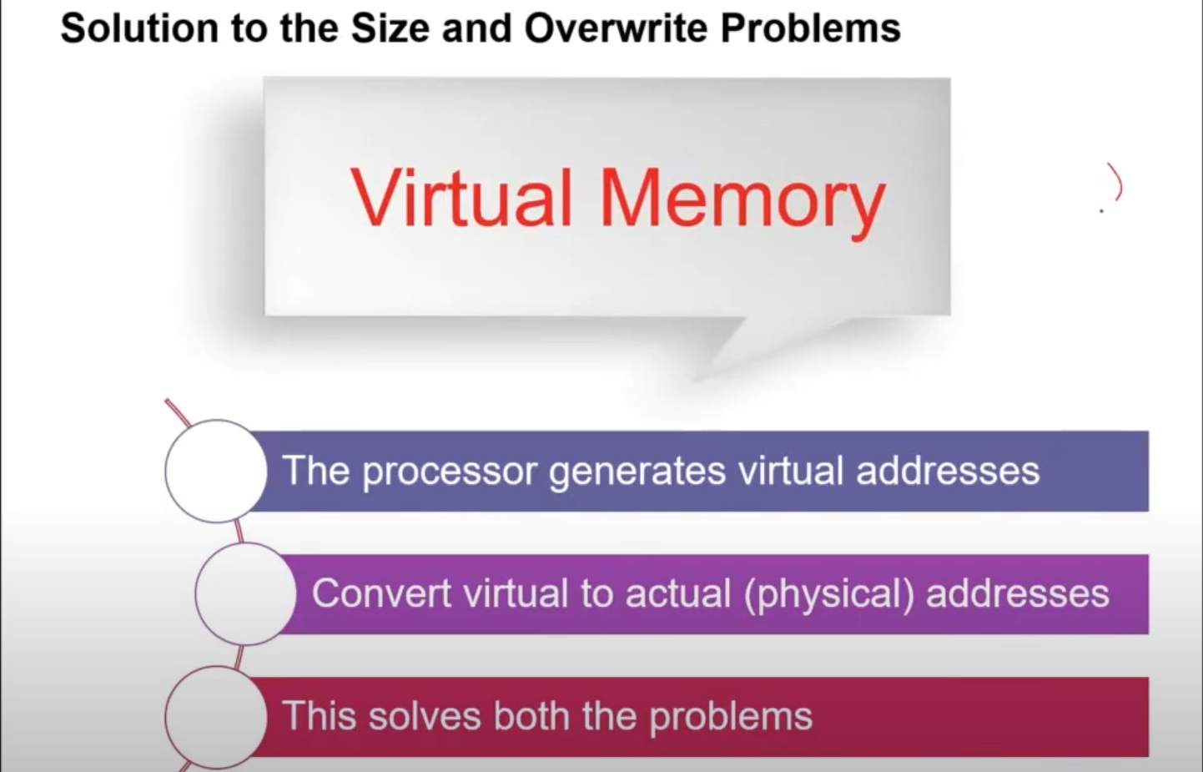

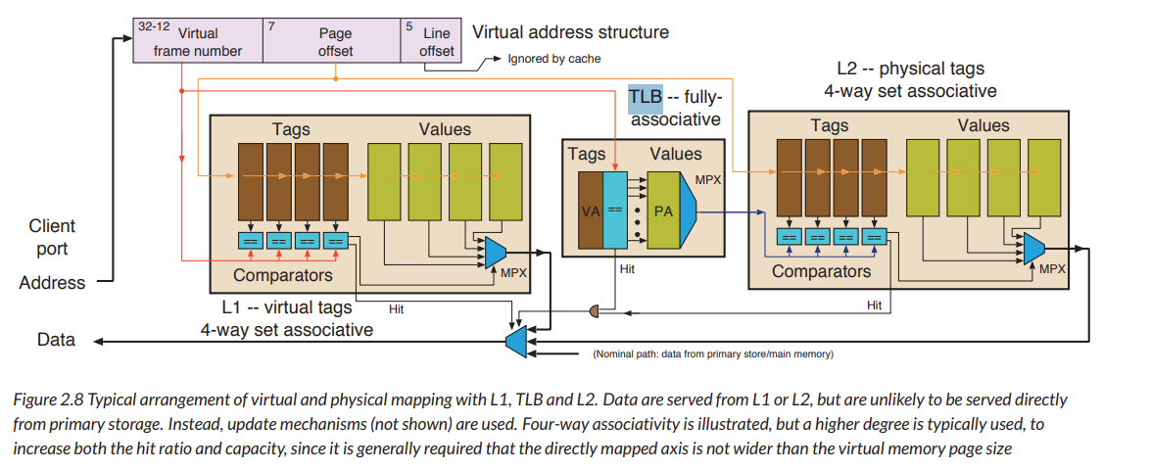

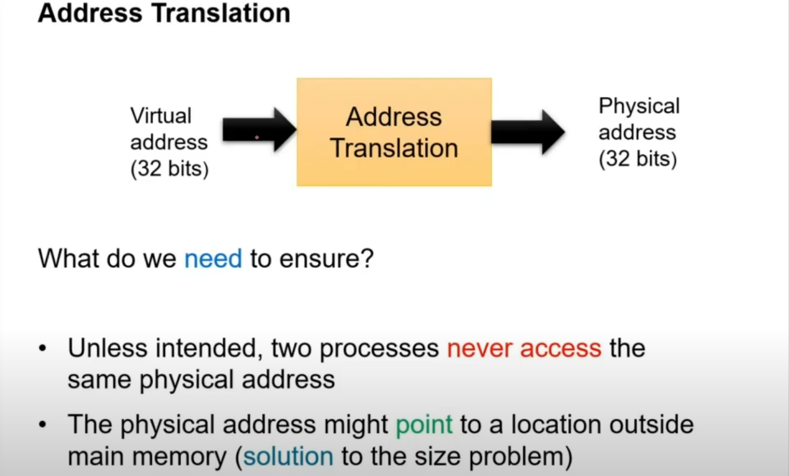

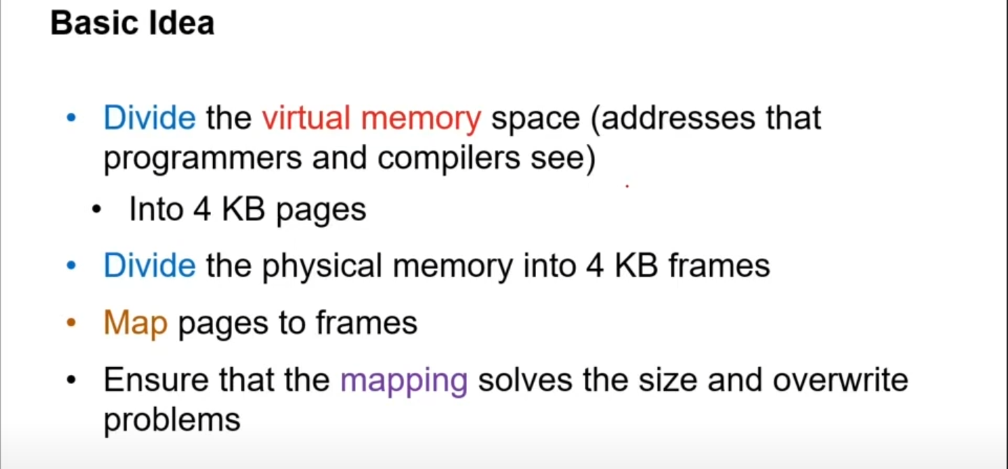

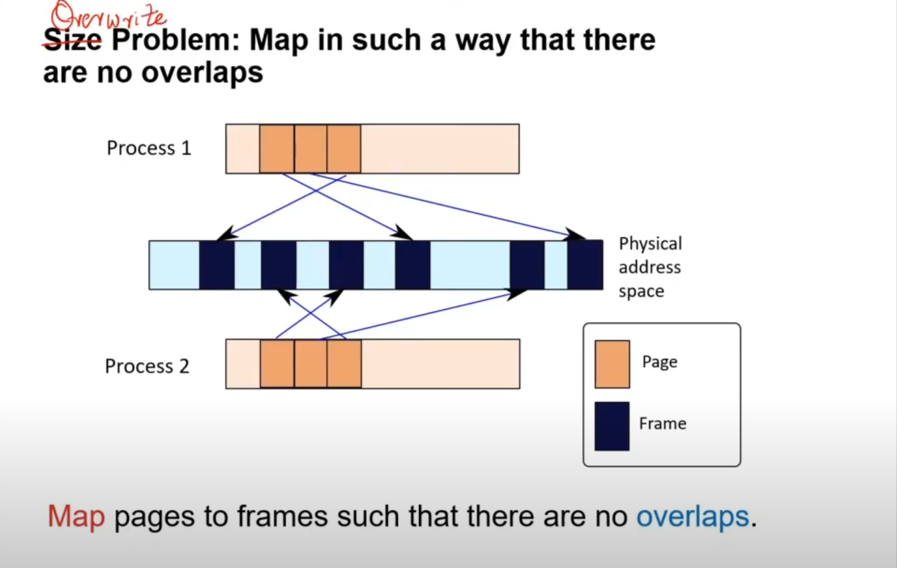

IPC : Interprocess Communication like shmem or mailbox or semaphore.

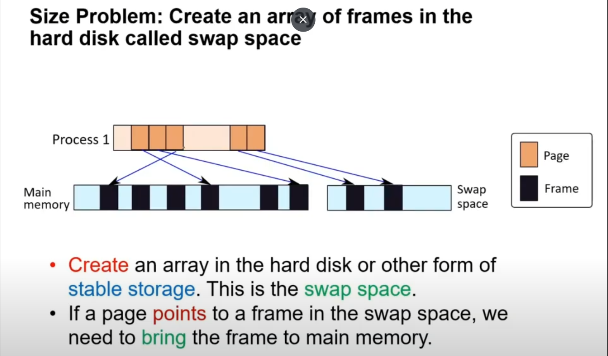

Main Memory : DRAM

Swap space : SSD or Hard disk. Its much slower.

{MM|Swap} : This becomes huge mapping for process.

Page Table : S/W. OS manages.

TLB : H/W

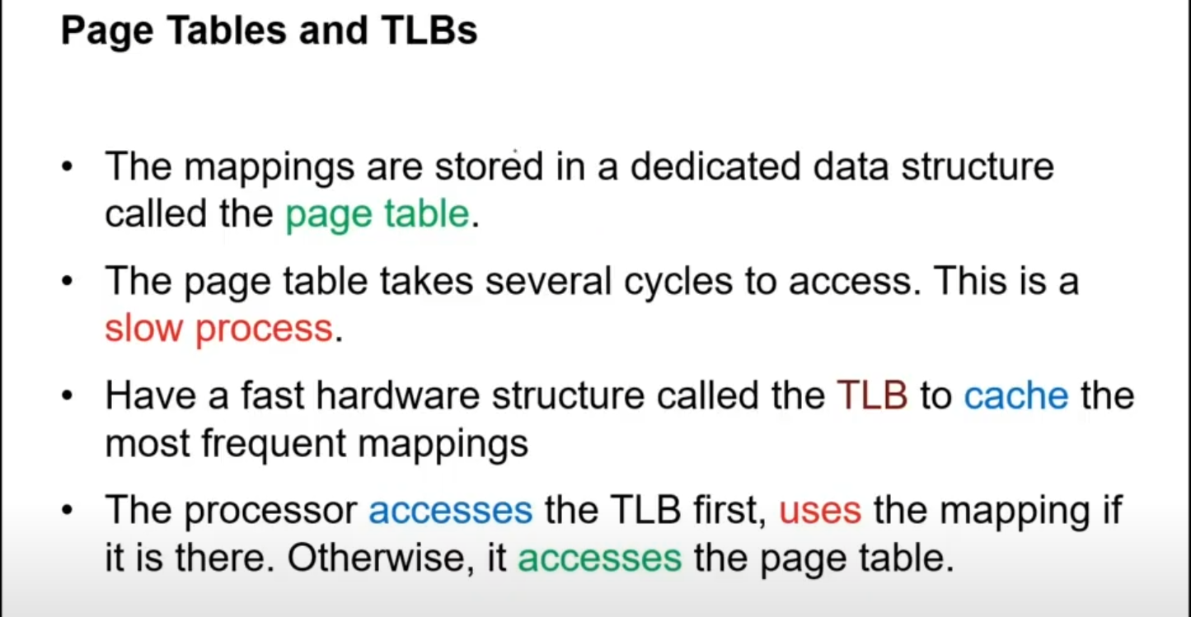

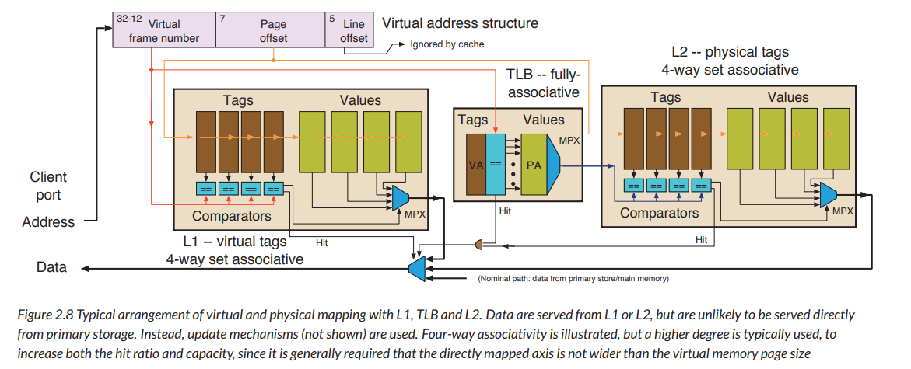

HWPTW : Hardware Page Table Walk. MSR Register : CR3 – Page table Register.

Software Page Walk.

